EADS NA Defense Test & Services

Software Design Document

ATXML to VISA Driver for the Ag E1445A
Arb (TETS Analog Subsystem)
AtXmlDriver – AtXmlArb_AgE1445A.dll

SDD – AtXmlArb_AgE1445A
Version 0.00
31 March 2006

This document and the information contained herein are proprietary to EADS NA Defense and may not be disclosed in whole or in part to any parties without the expressed written consent of EADS NA Defense.

© EADS NA Defense Test & Services
1222 Lucas Ave. Suite 200
St. Louis MO 63103
phone (314) 727 1337
fax (314) 727 6750

Software Design Document

Version 0.00

History of changes
0.00 Initial Version
Change Table

Change | Date | Paragraph

1 Scope 5
1.1 Identification 5
1.2 System Overview 5
1.3 Document Overview 5
2 Reference Documents 5
3 System-Wide Design Overview 5
3.1 Assumptions and Dependencies 5
3.2 General Constraints 6
3.3 Goals and Guidelines. 6
3.4 Safety and Security Considerations 6
3.5 Development Methods 6
4 System Architectural Design 6
4.1 System Components 7
4.2 Interface design 7
4.2.1 Common Interface (Arb_AgE1445A.cpp) 7
4.2.2 Per Instrument Instance (Arb_AgE1445A_T.cpp) 9
5 Detailed Design 10
5.1 Classification 10
5.2 Instrument IDs 10
5.3 atXml:port Names 10
5.4 Arb Programming Specifications 10
5.4.1 Programming Resolution 10
5.4.2 Programming Accuracy 10
5.5 Processing 10
6 Notes 10
6.1 IEEE1641 XML / Instrument Control Examples 10
6.1.1 Arb Gen 10

Scope

Identification
The software configuration component AtXmlArb_E1445A.dll provides the software routines necessary to control the TETS Analog System Arb, the AgE1445A.

System Overview
The TETS CICL provides a TE Interface to permit the TPS/TE to send XML signal descriptions to the test system instruments. Each instrument manufacturer provides an IVI/PnP/VISA API to control the instrument. The module defined herein provides the control of the AgE1445A by processing the XML signal descriptions into manufacturer API calls. The AtXmlArb_E1445A.dll accepts the TETS CICL TE Interface XML signal descriptions that describe the action and signal modifiers as described in the standard atXml Test Signal Framework (TSF) Library and IEEE 1641 Basic Signal Component (BCS) layer descriptions. The signal descriptions are processed to control the instrument via the IVI/PnP/VISA API. In addition to the standard TSF and BSC sensor functionality, the use of specified “Generic Measurements” are allowed.

In addition to the XML interface, several standard TETS CICL interface functions are also provided for status, station calibration data (e.g., Path Loss Compensation (PLC)), and low level control.

Document Overview
This document defines the detailed software design for the TETS XML driver for the AgE1445A. The value ranges of all the IEEE1641 BSC attributes and how they are used to control the AgE1445A are also specified within. This document provides a detailed definition of the “Generic Measurements” implemented. This document provides a detailed description of the standard TETS CICL functions.

Reference Documents
- DEFCOT&S-3560-SDD-001 CICL Software for TETS Software Detailed Design
- EADSSTL-ATML-DSG EADS PAWS WCEM Software Development Style Guide For ATML Output

System-Wide Design Overview
The TETS CICL provides a TE Interface that supports XML signal descriptions (i.e., IEEE1641 TSF/BSC). These signal descriptions are passed directly to this XML to VISA processor. In addition the TETS CICL requires direct access to status, calibration data, and low level control features of the instrument.

Assumptions and Dependencies
The following assumptions and dependencies are made:

- The TETS signal descriptions will conform to the IEEE1641 standard TSF/BSC definitions.
- When “Generic Measurements” are used, the TETS signal descriptions will only use “Generic Measurements” specified in this document.
- The full instrument range will be implemented when they exceed the ranges in the system requirements specification.
- The full functionality of the instrument will be implemented to the extent possible where the XML mapping can be defined. (Detailed below).

General Constraints
The sections below will detail which of the IEEE 1641 BSC attributes are used and how they are used to control the AgE1445A. The sections below will detail which “Generic Measurements” are allowed and details of how the measurement is taken.

Goals and Guidelines.
- Implement the full range and functionality as can be supported by the TETS XML signal description.

Safety and Security Considerations
No safety or security considerations for this module.

Development Methods
As described in the “EADS PAWS WCEM Software Development Style Guide For ATML Output.”

System Architectural Design
The TETS XML Driver provides a TETS specific common interface for each instrument. A common set of interfaces are provided to provide the instrument’s operation within the TETS Architecture. (See the “EADS PAWS WCEM Software Development Style Guide For ATML Output” for details). The essence of the XML driver is defined as a class CArb_AgE1445A. When multiple instruments (AgE1445As) are available in the station, an instance of the CArb_AgE1445A class will be instantiated. Therefore, the member variables and methods need only control a single instrument.
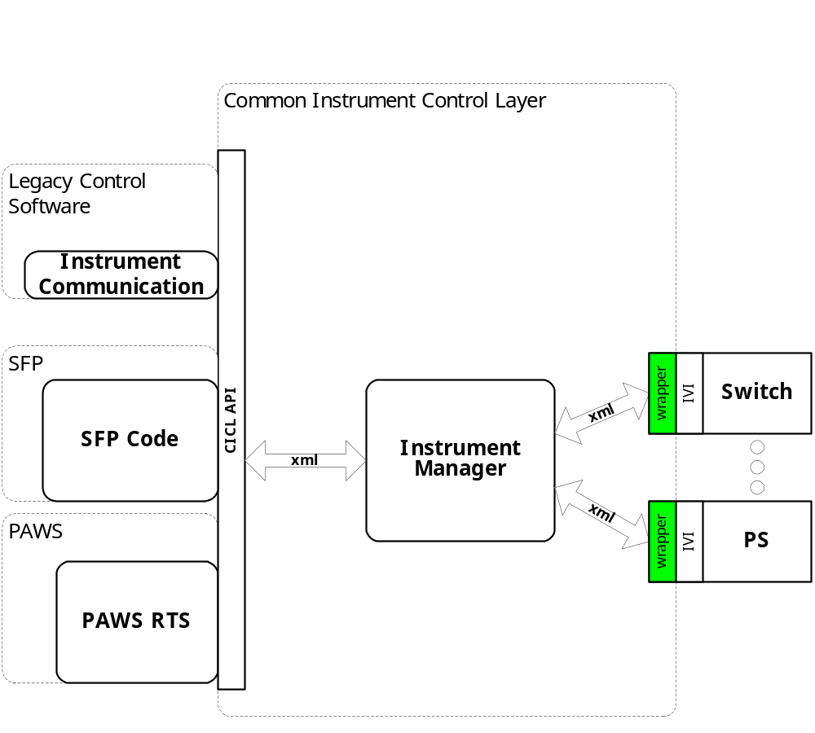
Figure 4.0 XML Driver Function Relationships

System Components
The XML driver will consist of:

- A Microsoft Visual C++ project to build the .dll
  - TETS XML standard interface functions
    - Arb_AgE1445A.cpp
  - Configuration Information
  - Arb_AgE1445A.rc
  - resource.h
  - The instrument specific driver file Arb_AgE1445A_T.cpp

Interface design

Common Interface (Arb_AgE1445A.cpp)
Function | Purpose
Initialize(int instno, char* instid, bool sim, int dbglvl, int prime_addr, int second_addr, int sub_mod_addr, CICL_XML_String* Response, int BufferSize) | This function is used to initialize the instrument, register the system assigned “instno” to the “Instid” (InstDrvrComponentID), obtain instrument availability status, and establish the device is in simulation mode and / or debug. This call may be issued multiple times to clear the instrument interface and alter the simulation mode or debug level.
Close(void) | This function shuts down the instrument and releases the device from active use status.
IssueSignal(int instno, CICL_XML_Snippet* SignalDescription, CICL_XML_String* Response, int BufferSize) | This function accepts the XML signal description, processes it, and returns a response.
IssueNativeCmds(CICL_XML_String* InstrumentCommands, CICL_XML_String* Response, int BufferSize) | This function accepts the XML string that contains an instno, and a native instrument command string. It processes it, and returns a response.
IssueDriverFunctionCall(int instno, CICL_XML_String* DriverFunction, CICL_XML_String* Response, int BufferSize) | This function accepts the XML string that contains a native instrument driver function call, processes it, and returns a response.
Status(int instno, CICL_XML_String* Response, int BufferSize) | This function queries the instrument for status and returns the status and any errors to CICL.
RegCal(int instno, CICL_XML_String* CalData) | This function registers the provided calibration data (e.g., PLC data) for use by the instrument driver.
RegisterTSF(CICL_XML_Filename* TSFSignalDefinition, CICL_XML_Filename* TSFLibrary, CICL_XML_Filename* STDTSF, CICL_XML_Filename* STDBSC) | This function registers a User TSF library data for this device.
Reset(int instno, CICL_XML_String* Response, int BufferSize) | This function is responsible for resetting the instrument. The “instno” 0 will be reserved for a RESETALL action and shall reset all the instrument instances initialized.
Ist(int instno, int Level, CICL_XML_String* Response, int BufferSize) | This function is responsible for performing the instrument built in self test. It returns the instrument status. Where Level:  CICL_IST_LVL_CNF  CICL_IST_LVL_IST  CICL_IST_LVL_BIT1 - …BIT5

Per Instrument Instance (Arb_AgE1445A_T.cpp)
Function | Purpose
CArb_AgE1445A(bool sim, int dbglvl, int prime_addr, int second_addr) | This function is used to initialize the instrument, obtain instrument availability status, and establish if the device is in simulation mode and / or debug.
~CArb_AgE1445A(void) | This function shuts down the instrument and releases the device from active use status.
SetupArb_AgE1445A(CICL_XML_Snippet* SignalDescription, CICL_XML_String* Response, int BufferSize) | This function is the entry point for the setup action. The Signal Description is the XML containing BSC and standard TSF signal components.
StatusArb_AgE1445A(CICL_XML_Snippet* SignalDescription, CICL_XML_String* Response, int BufferSize) | This function is the entry point for the status action. The Signal Description is the XML containing BSC and standard TSF signal components.
FetchArb_AgE1445A(CICL_XML_Snippet* SignalDescription, CICL_XML_String* Response, int BufferSize) | This function is the entry point for the fetch action. The Signal Description is the XML containing BSC and standard TSF signal components.
InitiateArb_AgE1445A(CICL_XML_Snippet* SignalDescription, CICL_XML_String* Response, int BufferSize) | This function is the entry point for the initiate action. The Signal Description is the XML containing BSC and standard TSF signal components.
ResetArb_AgE1445A(CICL_XML_Snippet* SignalDescription, CICL_XML_String* Response, int BufferSize) | This function is the entry point for the reset action. The Signal Description is the XML containing BSC and standard TSF signal components.
CloseArb_AgE1445A(CICL_XML_Snippet* SignalDescription, CICL_XML_String* Response, int BufferSize) | This function is the entry point for the close action. The Signal Description is the XML containing BSC and standard TSF signal components.
OpenArb_AgE1445A(CICL_XML_Snippet* SignalDescription, CICL_XML_String* Response, int BufferSize) | This function is the entry point for the open action. The Signal Description is the XML containing BSC and standard TSF signal components.
SendNativeCmds(CICL_XML_String* InstrumentCommands, CICL_XML_String* Response, int BufferSize) | This function accepts the XML string that contains a native instrument command string, processes it, and returns a response.
DoDriverFunctionCall(CICL_XML_String* DriverFunction, CICL_XML_String* Response, int BufferSize) | This function accepts the XML string that contains a native instrument driver function call, processes it, and returns a response.

Detailed Design

Classification
This module is unclassified.

Instrument IDs
Instrument ID is not used to locate the instrument. Device address is found in the TestStationInstance.xml file.

atXml:port Names
When used in an atXml:port element in an XML Signal Description, the following port names are allowed and have the specified meaning:

Port Name | Meaning | Allowable Usage
Waveform | Output Port
TrigHi | Arm Input

Arb Programming Specifications

Programming Resolution
TBD

Programming Accuracy
TBD

Processing
There are no special processing requirements other than normal IEEE 1641 to instrument programming.

Notes

IEEE1641 XML / Instrument Control Examples
The following sections give examples of the IEEE 1641 code with all the accepted options. Generally, ATLAS optional items are also optional in the XML.

Arb Gen
AC Signal:
<Signal Name="ARB_SIGNAL" Out="Waveform">
<port name="Waveform" In="Load"/>
<Sinusoid name="AC_Component" amplitude="3 V" frequency="500000 Hz"/>
<Constant name="DC_Level" amplitude="2 V"/>
<Sum name="Sum" In="DC_Level AC_Component"/>
<LowPass name="Filter" cutoff="10000000.000000Hz" In="Sum" />
<Load name="Load" resistance="50 Ohm" In="Filter"/>
</Signal>
Square Wave:
<Signal Name="ARB_SIGNAL" Out="Waveform">
<port name="Waveform" In="Load"/>
<SquareWave name="SquareWave_Component" amplitude="3 V" period="2e-006 Sec"/>
<Constant name="DC_Level" amplitude="2 V"/>
<Sum name="Sum" In="DC_Level SquareWave_Component"/>
<LowPass name="Filter" cutoff="10000000.000000Hz" In="Sum" />
<Load name="Load" resistance="50 Ohm" In="Filter"/>
</Signal>

Triangle Wave
<Signal Name="ARB_SIGNAL" Out="Waveform">
<port name="Waveform" In="Load"/>
<Triangle name="TriangleWave_Component" amplitude="3 V" period="2e-006 Sec"/>
<Constant name="DC_Level" amplitude="2 V"/>
<Sum name="Sum" In="DC_Level TriangleWave_Component"/>
<LowPass name="Filter" cutoff="10000000.000000Hz" In="Sum" />
<Load name="Load" resistance="50 Ohm" In="Filter"/>
</Signal>

DC Signal:
<Signal Name="ARB_SIGNAL" Out="Waveform">
<port name="Waveform" In="Load"/>
<Constant name="DC_Level" amplitude="3 V"/>
<Load name="Load" resistance="50 Ohm" In="DC_Level"/>
</Signal>

Triggered
<Signal Name="ARB_SIGNAL" Out="Waveform" In="TrigHi">
<port name="Waveform" In="Load"/>
<port name="TrigHi"/>
<Instantaneous name="Trigger" nominal="1.6V" condition="LT" In="TrigHi"/>
<Sinusoid name="AC_Component" Sync="Trigger" amplitude="3.5 V" frequency="500000 Hz"/>
<Constant name="DC_Level" amplitude="0 V"/>
<Sum name="Sum" In="DC_Level AC_Component"/>
<LowPass name="Filter" cutoff="10000000.000000Hz" In="Sum" />
<Load name="Load" resistance="50 Ohm" In="Filter"/>
</Signal>

Waveform
<Signal Name="ARB_SIGNAL" Out="Waveform">
<port name="Waveform" In="Load"/>
<WaveformStep name="Waveform_Component" samplingInterval="0.002000000000 sec" points="-2, -1.2, -0.8, -0.4, -0.1, -0.3, 0.4, 0.2" />
<Constant name="DC_Level" amplitude="0 V"/>
<Sum name="Sum" In="DC_Level Waveform_Component"/>
<LowPass name="Filter" cutoff="10000000.000000Hz" In="Sum" />
<Load name="Load" resistance="50 Ohm" In="Filter"/>
</Signal>

